**EXP 1:** Create a simple cloud software application for Property Buying & Rental process (In Chennai city) using any Cloud Service Provider to demonstrate SaaS

**STEP 1:** GO TO ZOHO.COM

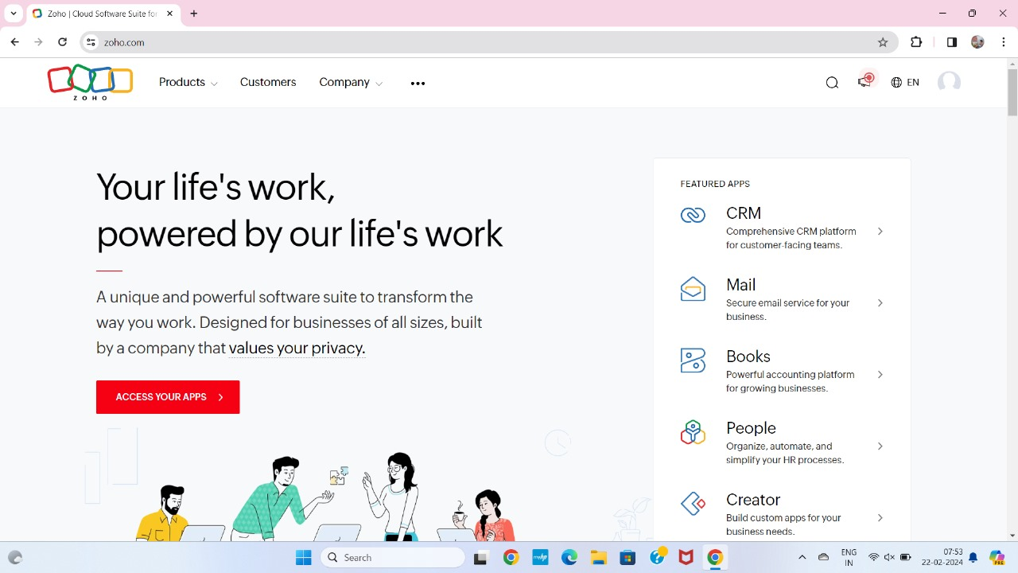

STEP 2: LOGIN TO ZOHO.COM

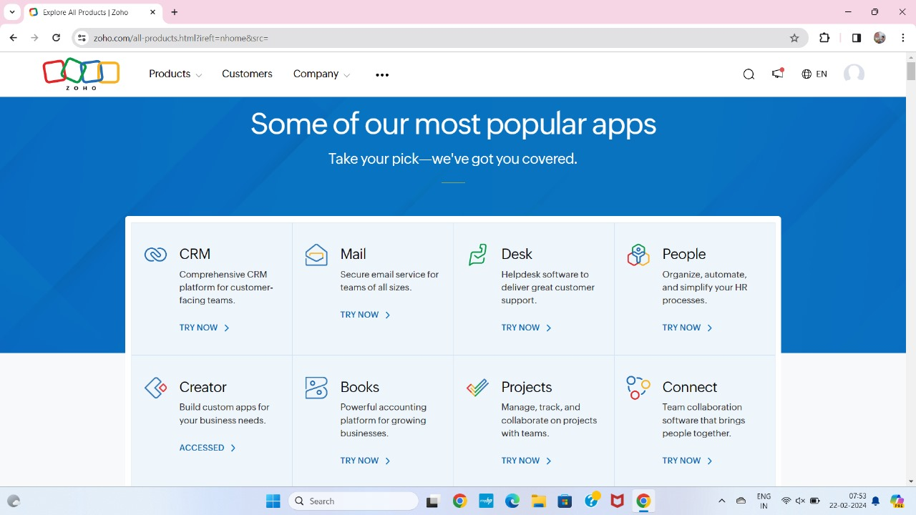

STEP 3: SELECT A CREATE FROM SCRATCH

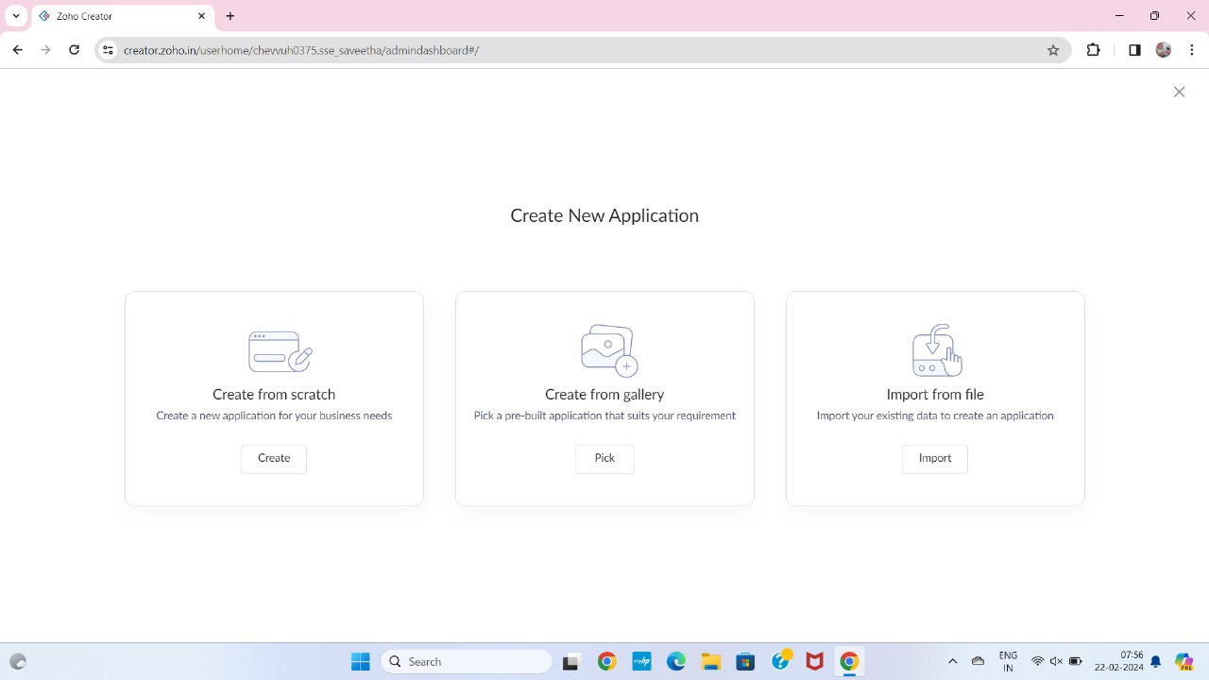

STEP 4: SELECT APPLICATION NAME AS PROPERTY BUYING AND RENTAL

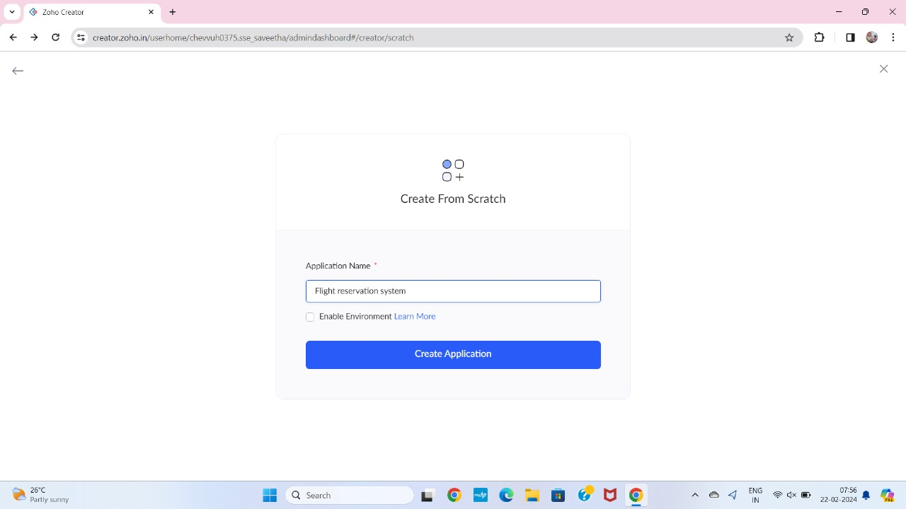

STEP5: CREATE A NEW FORM

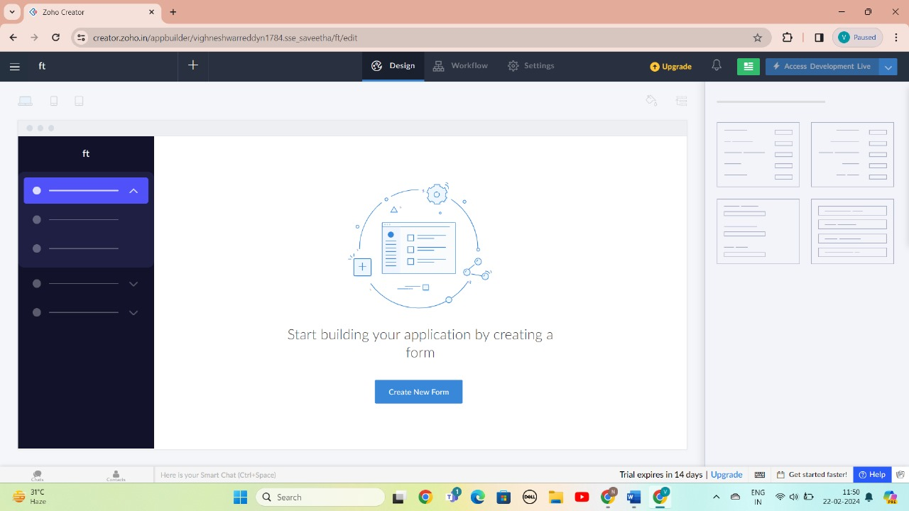

STEP 6: SELECT BASIC FIELD FROM GIVEN BELOW AND DEVELOP APPLICATION

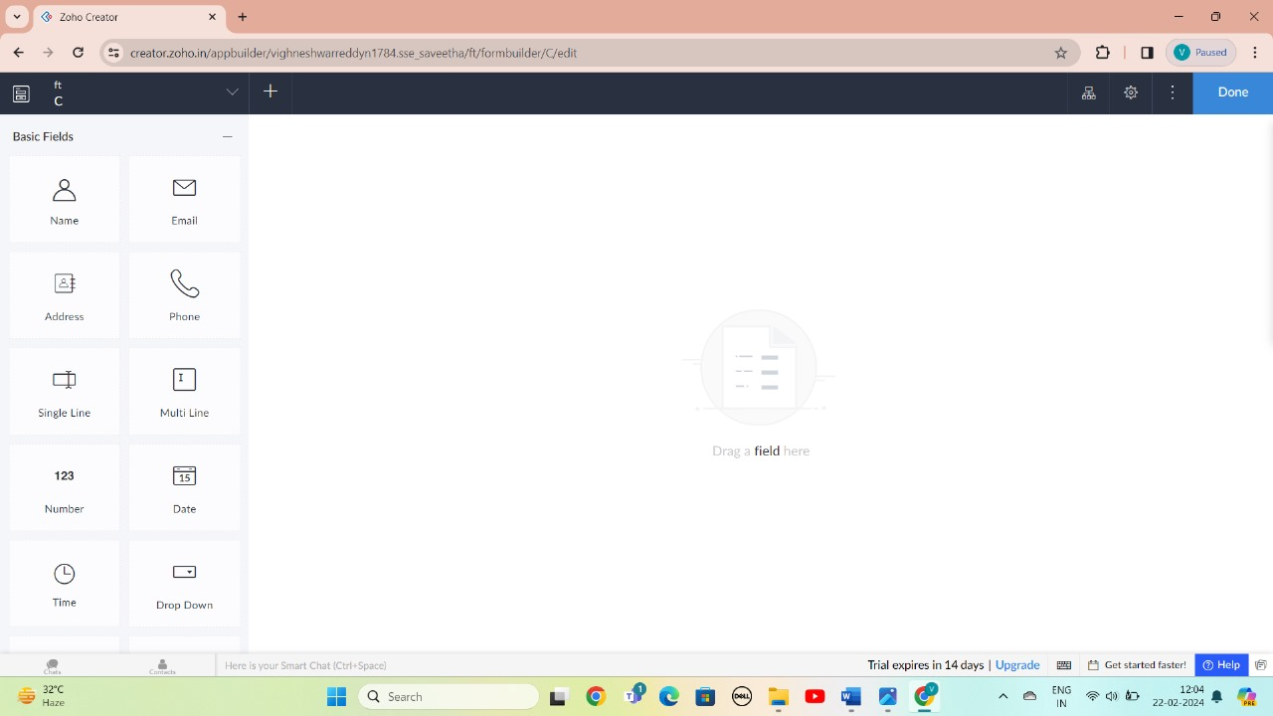

STEP 7: THE SOFTWARE HAS BEEN CREATED LOGIN PAGE

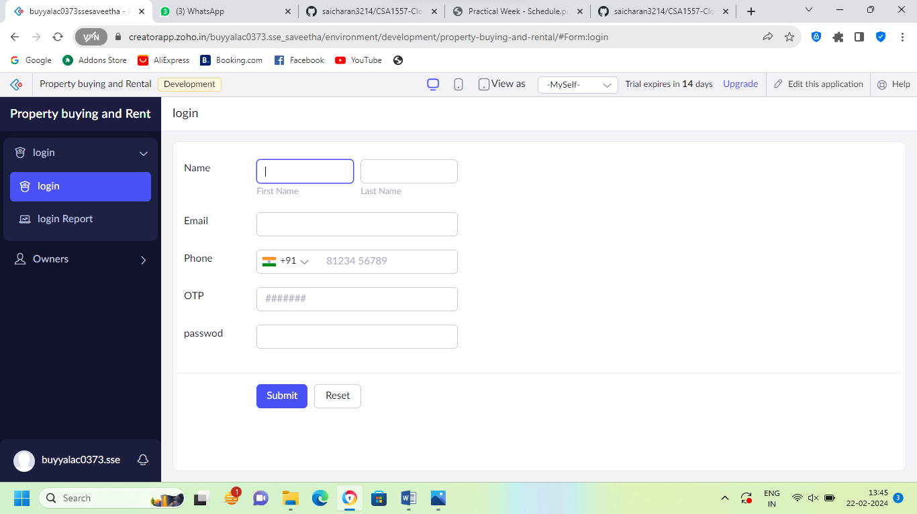

STEP 8: THE SOFTWARE HAS BEEN CREATED OWNER DETAILS

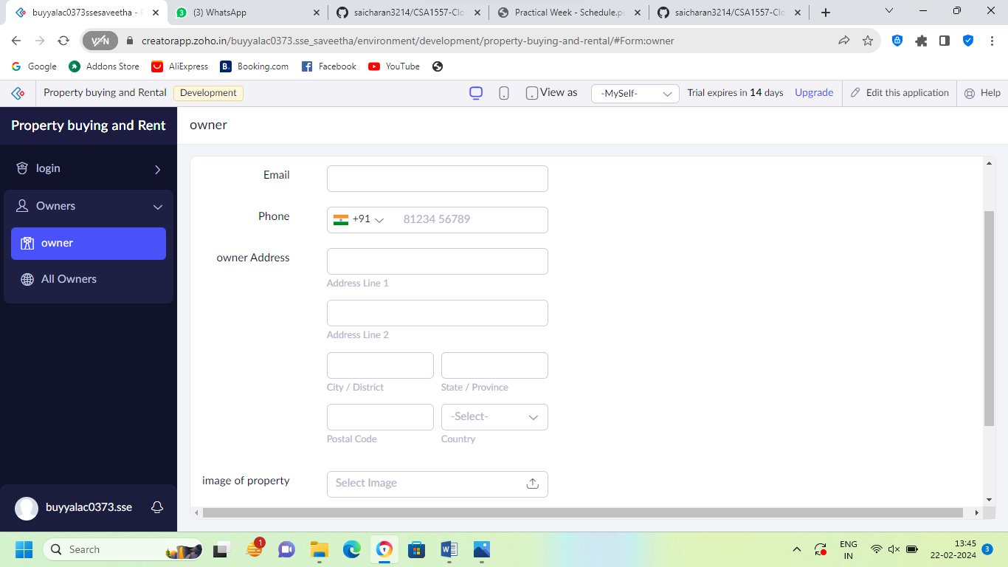

STEP 9: THE SOFTWARE HAS BEEN CREATED BUYER OR TENANT

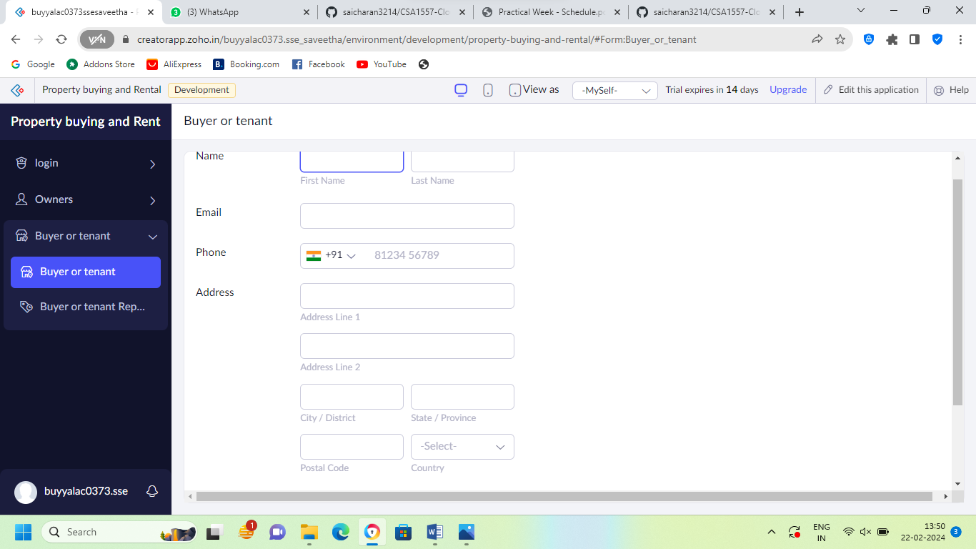

STEP 10: THE SOFTWARE HAS BEEN CREATED VERIFICATION

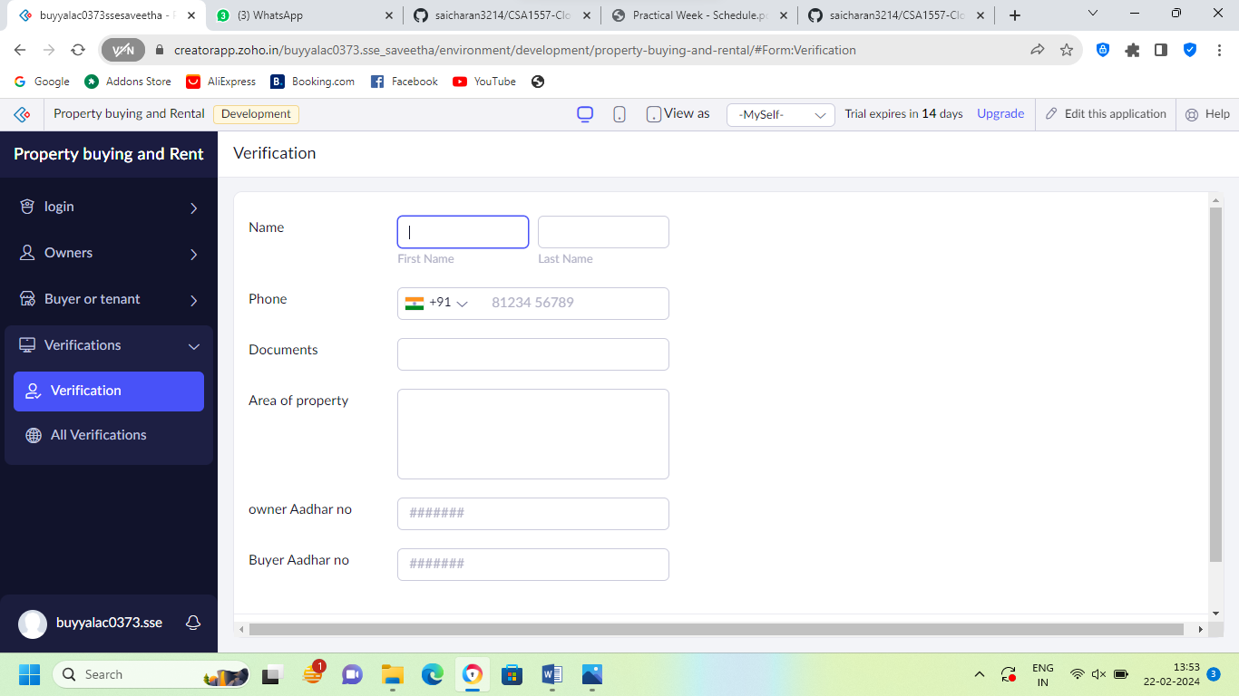

STEP 11: THE SOFTWARE HAS BEEN CREATED PAYMENT

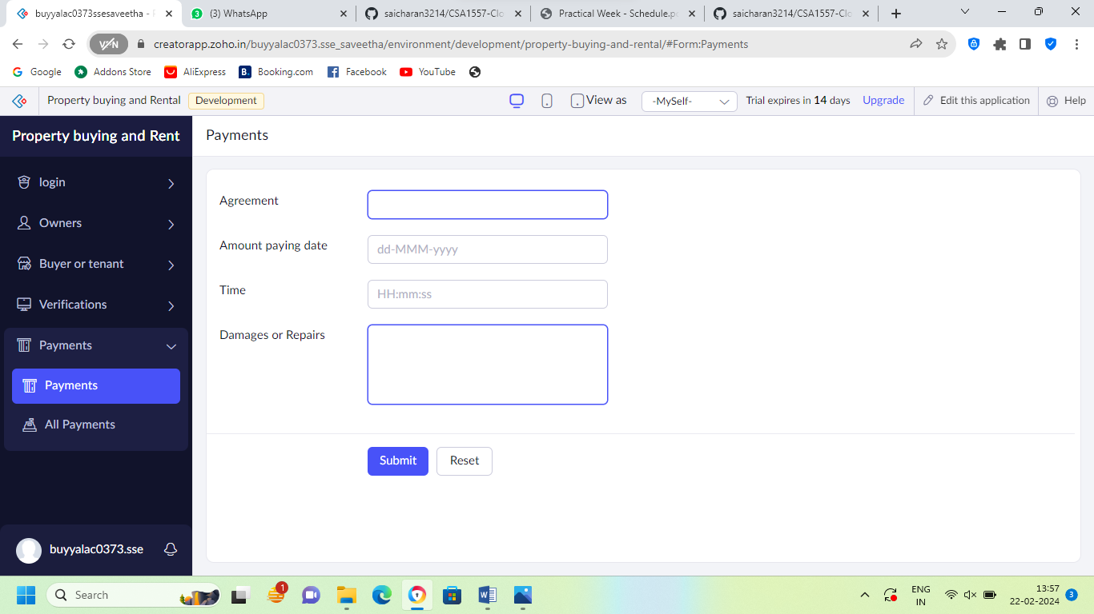

STEP 12: THE SOFTWARE HAS BEEN CREATED

